**Experiment No : 6**

Name : Rajashri Jaywant Patil

**Title : MySQL Joins and subqueries.**

**1.Create Database :**

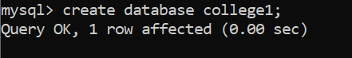

**2.Use Database :**



**3.Create Table :**



**4.Insert Records :**

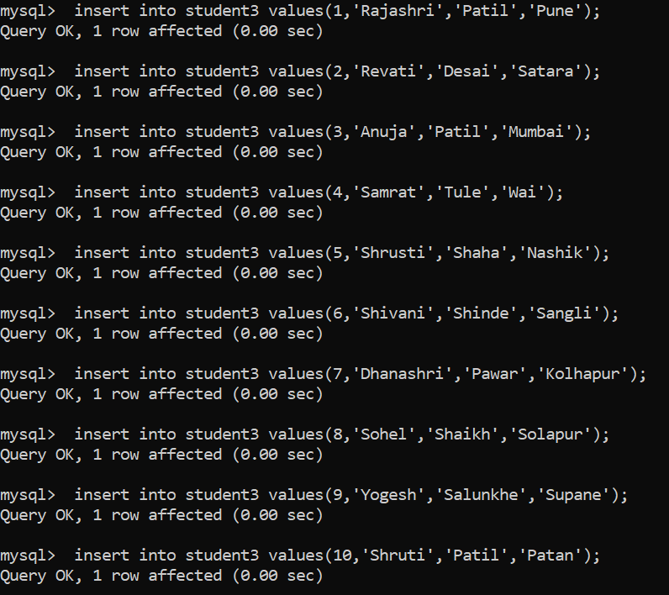

**5.Show Table :**

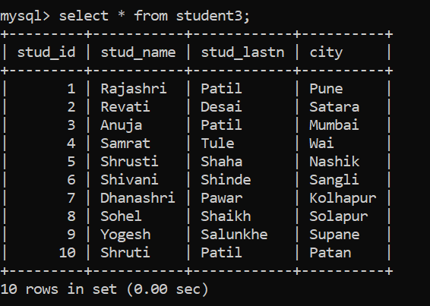

**6.Create 2nd Table :**



**7.Insert Records :**

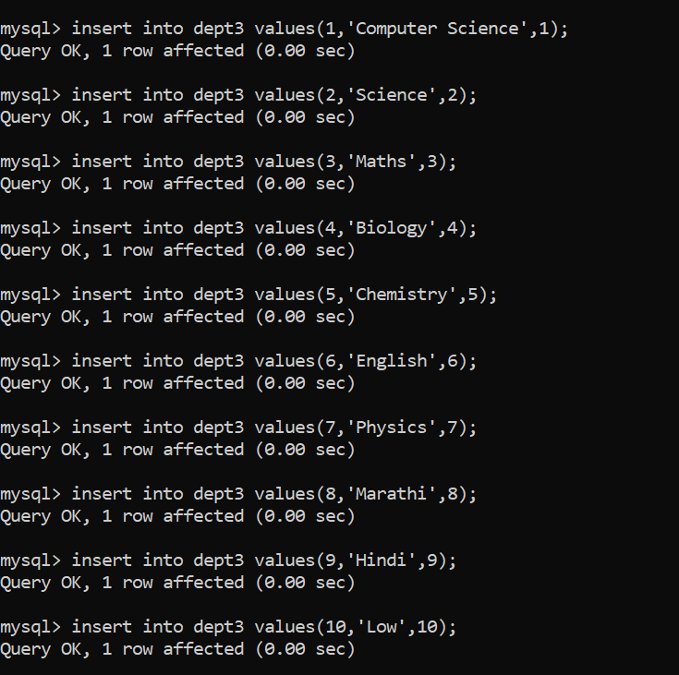

**8.Show Tables :**

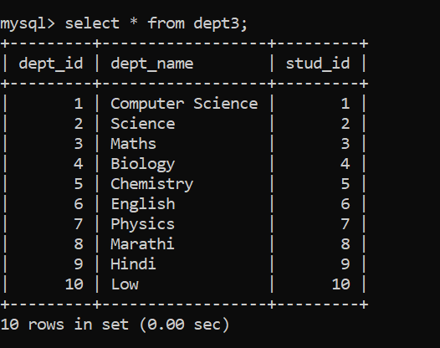

* **MYSQL Joins :**

**1.INNER JOIN :**

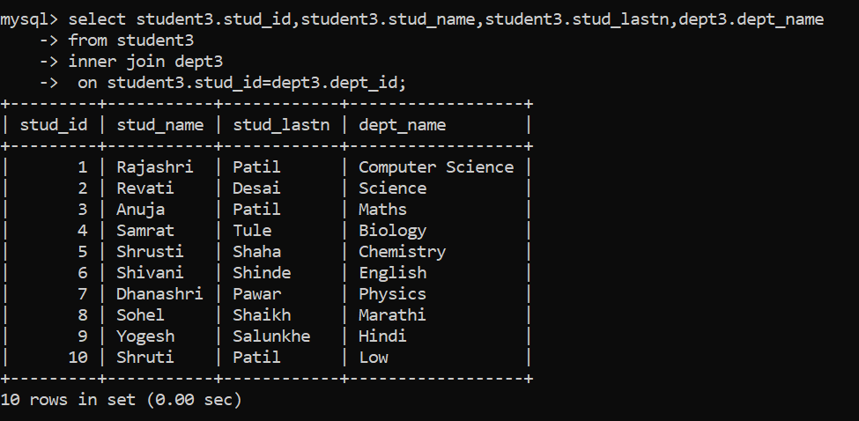

**2.LEFT JOIN :**

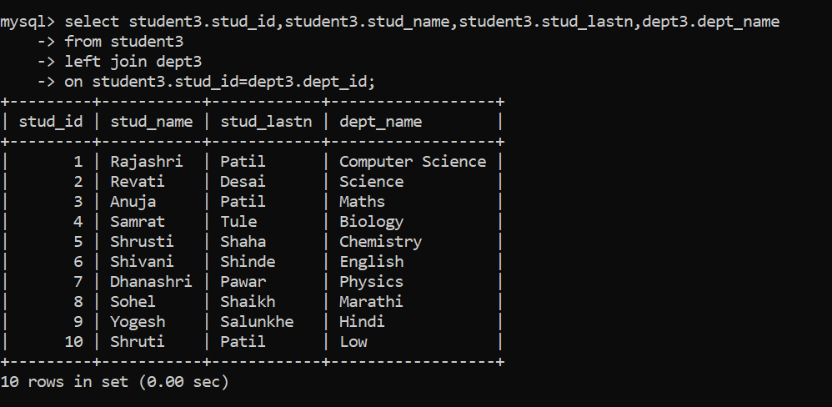

**3.RIGHT JOIN :**

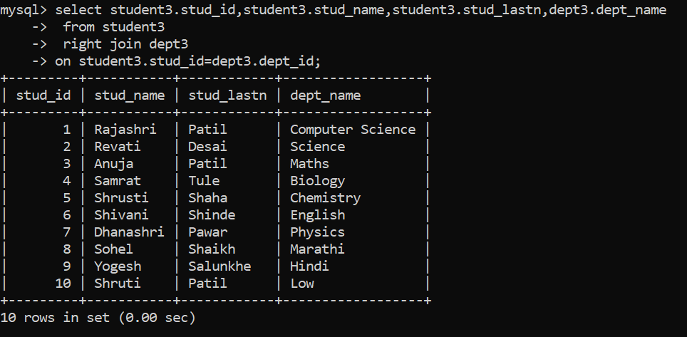

**4.CROSS JOIN :**

